**Experiment 8: Water Purification: Hardness Estimation by**

**EDTA Method and its Removal using Ion-exchange Resin**

**Name:** Vidhi Shah

**Reg. No.:** 21BCE1297

**Slot:** L11-L12

**Date:** 30/11/21

**Titration-I: Standardization of EDTA**

**Table:**

|  |  |  |  |  |
| --- | --- | --- | --- | --- |
| **S. No.** | **Volume of standard hard water (mL)** | **Burette reading (mL)** | | **Volume of EDTA**  **(V1, mL)** |
| **Initial** | **Final** |
| 1 | **20** | **0** | **20.4** | **20.4** |
| 2 | **20** | **0** | **20.4** | **20.4** |
| 3 | **–** | **–** | **–** | **–** |
| **Concordant titer value** | | | | **20.4** |

**Calculation:**

20 mL of given hard water consumes V1 mL of EDTA

20 mg of CaCO3 requires V1 mL of EDTA for complexation

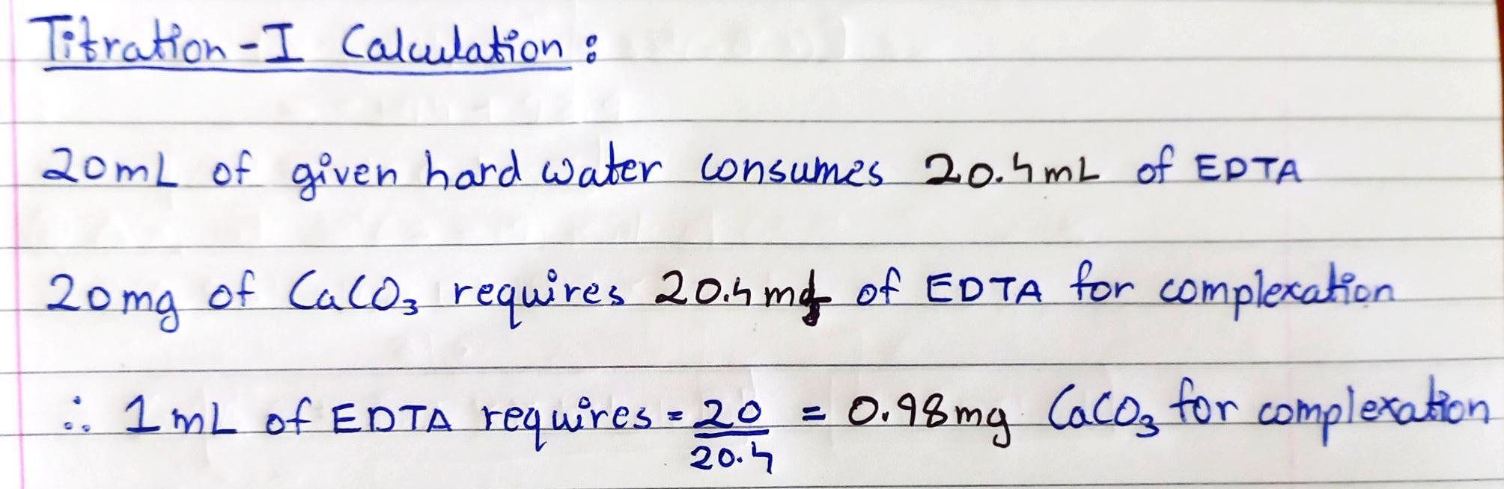 **1 mL of EDTA** requires = **20/V1** mg = **0.98 mg** CaCO3 for complexation

**Titration-II: Estimation of total hardness of hard water sample**

**Table:**

|  |  |  |  |  |
| --- | --- | --- | --- | --- |
| **S. No.** | **Volume of sample hard water (mL)** | **Burette reading (mL)** | | **Volume of EDTA**  **(V2, mL)** |
| **Initial** | **Final** |
| 1 | **20** | **0** | **8.2** | **8.2** |
| 2 | **20** | **0** | **8.2** | **8.2** |
| 3 | **–** | **–** | **–** |  |
| **Concordant titer value** | | | | **8.2** |

**Calculation:**

From Titration 1, we have the following relation:

 1 mL of EDTA requires = 0.98 mg CaCO3 for complexation

From Titration 2,

20 mL of sample hard water consumes = V2 mL of EDTA.

= V2 x 20/V1 mg of CaCO3 eq.

1000 mL of hard water sample consumes = V2 x ~~20~~/V1×1000/~~20~~

= V2/V1×1000 ppm

 Total hardness of the water sample = **X ppm = 401.96 ppm**

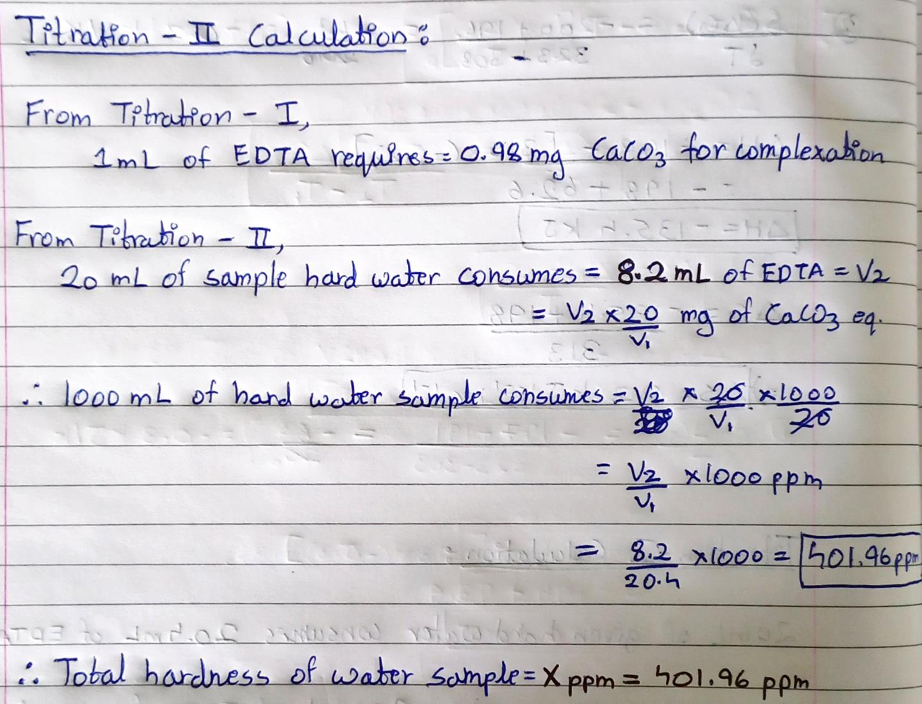

**Titration-3: Removal of hardness using ion exchange method**

**Table:**

|  |  |  |  |  |
| --- | --- | --- | --- | --- |
| **S. No.** | **Volume of sample hard water (mL)** | **Burette reading (mL)** | | **Volume of EDTA**  **(V3, mL)** |
| **Initial** | **Final** |
| 1 | **20** | **0** | **2.6** | **2.6** |
| 2 | **20** | **0** | **2.6** | **2.6** |
| 3 | **–** | **–** | **–** | **–** |
| **Concordant titer value** | | | | **2.6** |

**Calculation:**

From Titration 1, we have the following relation:

 1 mL of EDTA requires = 20/V1 mg CaCO3 for complexation

From this relation, it can be seen that

20 mL of water sample after softening through the column consumes = V3 mL of EDTA.

= V3 x 20/V1 mg of CaCO3 eq.

 1000 mL of water sample after softening through the column consumes = V3 x ~~20~~/V1×1000/~~20~~

= V3/V1×1000 ppm

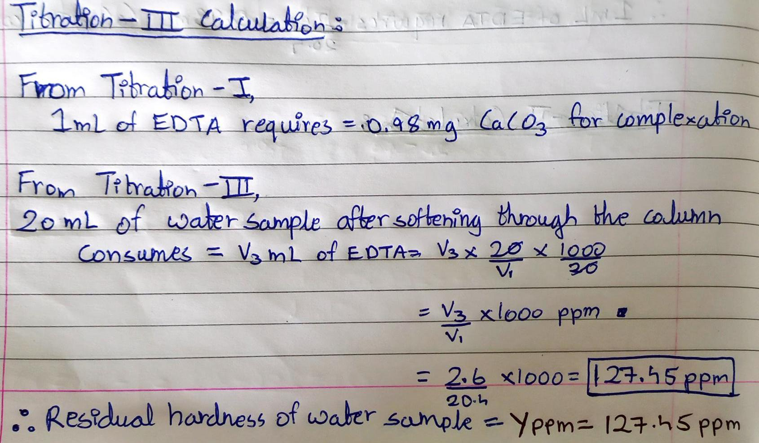  Residual hardness of the water sample = **Y ppm = 127.45 ppm**

**Result:**

1. Total hardness of the water sample = **X ppm = 401.96 ppm**
2. Residual hardness in the water sample = **Y ppm = 127.45 ppm**
3. Hardness removed through the column = **(X-Y) ppm = 274.51 ppm**